

Department of Computer Science & Engineering

LAB-6F-04
Web Tech Lab / Network Lab

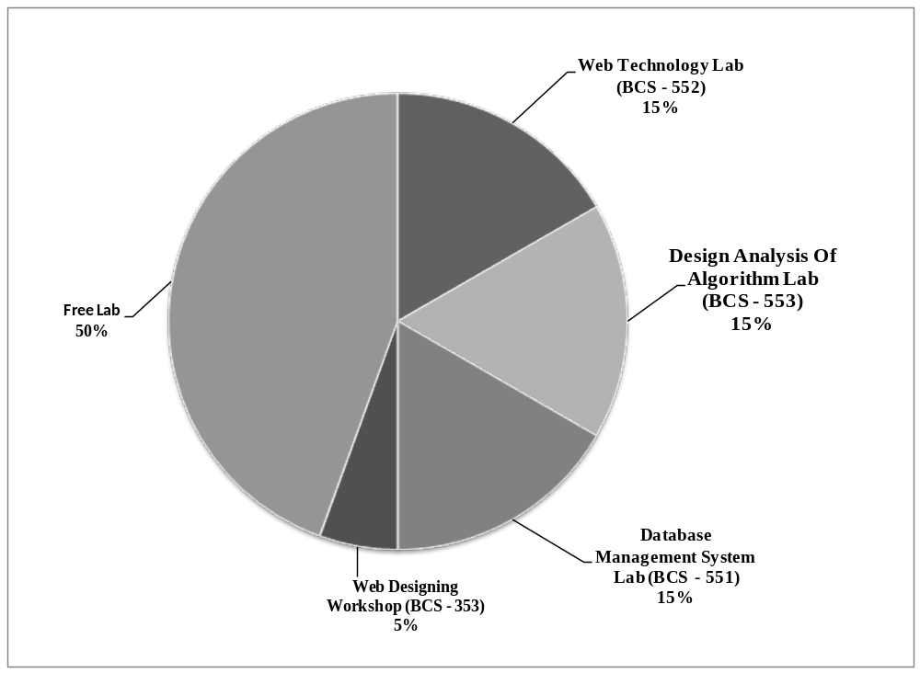Lab Occupancy Odd Semester 2024-2025

Mr. Rinku Singh | Mr. Ram Jee Dixit | Dr. Sheelesh Kr Sharma
Lab Technician | Lab In-charge | Head of Department -MCA

